Segmentation
Running Configurations
Router0
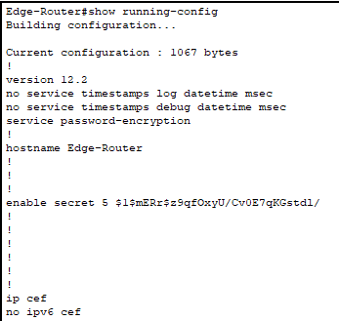
- Password encryption on
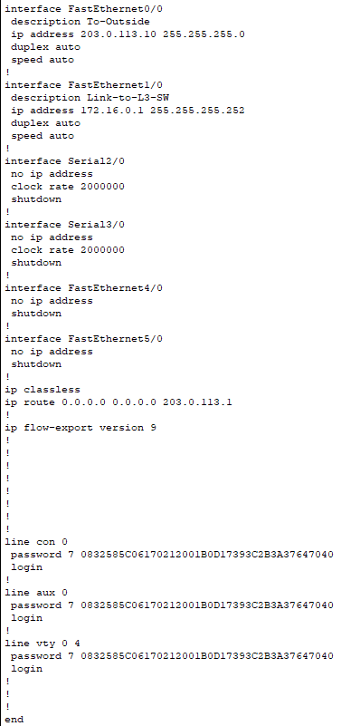

Switches
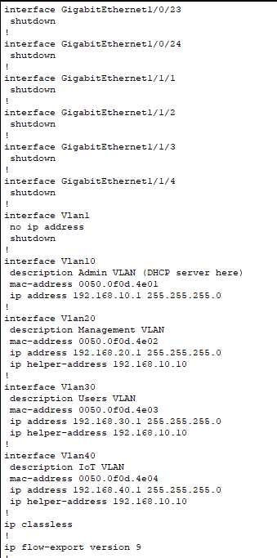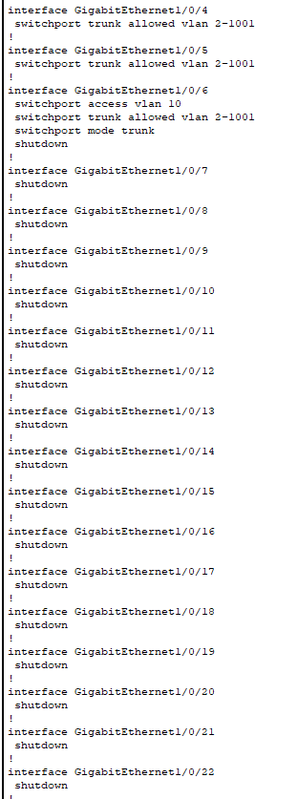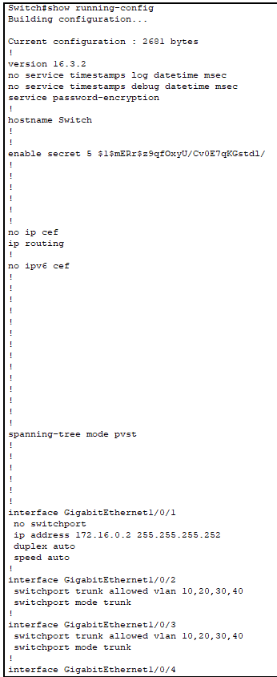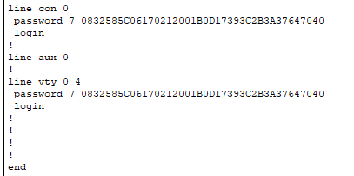

Configurated VLANs
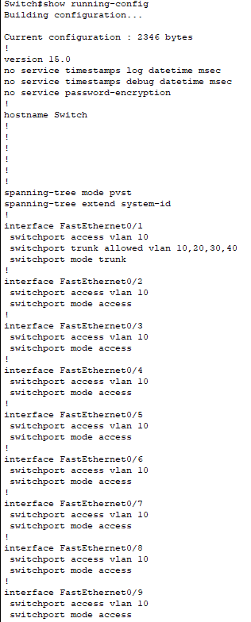
VLAN 10

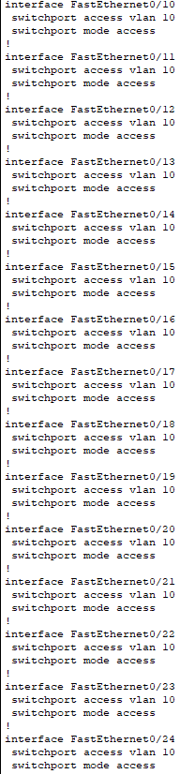
VLAN 10

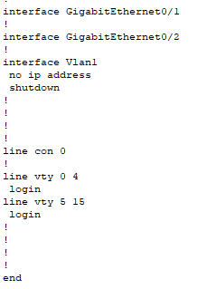
Vlan 10 Admin/Servers

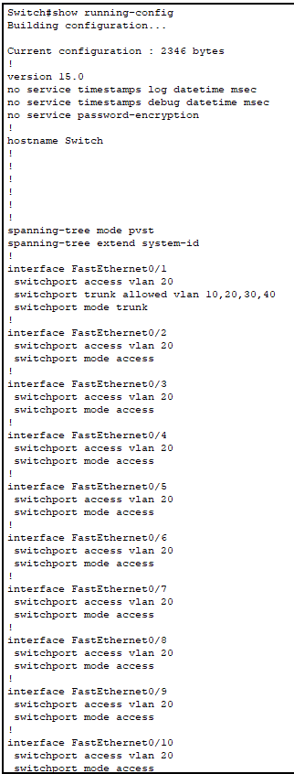

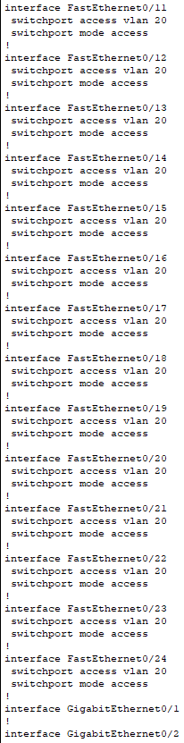

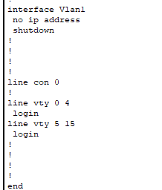
VLAN 20 Management
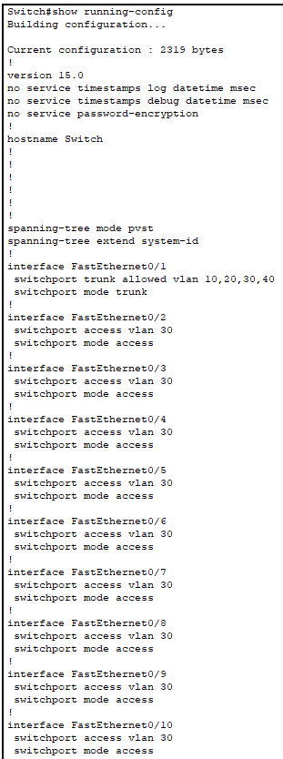

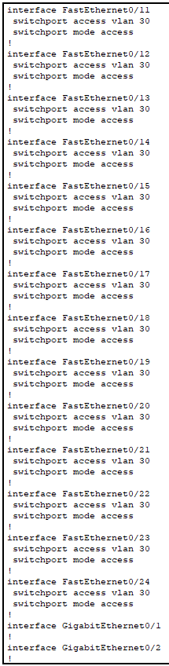

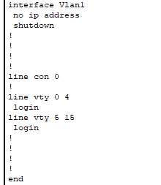
VLAN 30 Users

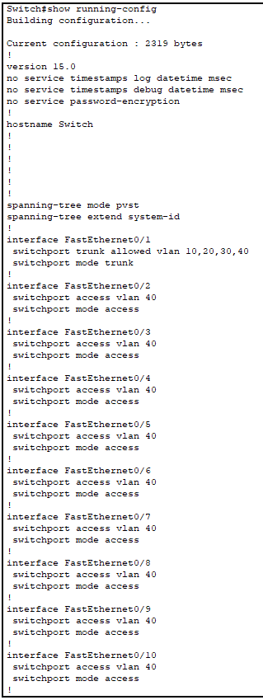

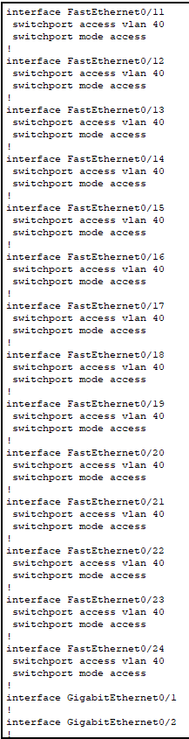

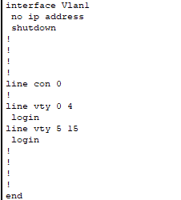
VLAN 40 IOT
IP interface Brief after closing unused Ports
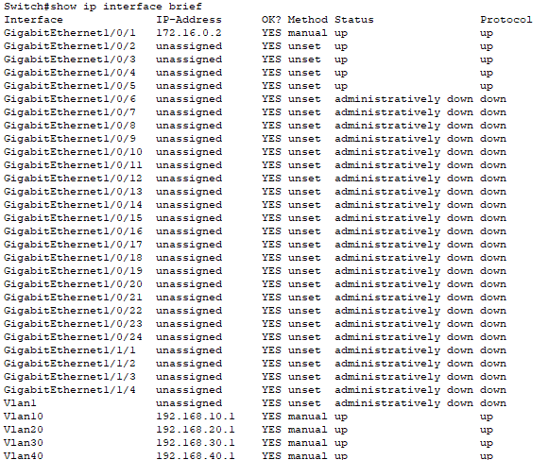
- initial testing revealed external access to internal network is denied by network segmentation however internal devices can still communicate between vlans, thus can move laterally
- testing also revealed l2 switches did not have passwords on them (to be fixed)
- l3 switch had active open ports that have since been closed
- passwords on l3 switch and edge router are present
Internal Network

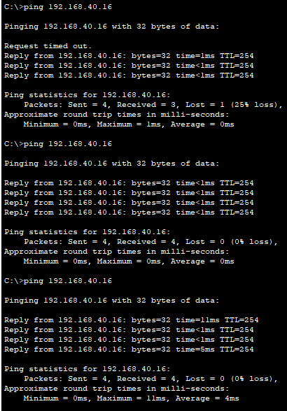
Ping from inside attacker to IoT3 Vlan 40 status: success

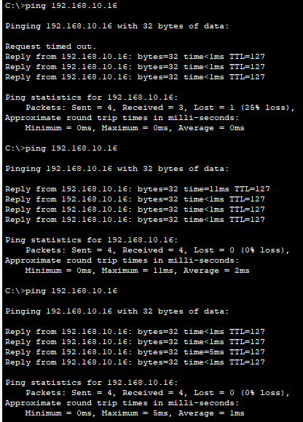
Ping from inside attacker to PC0 Vlan 10 status: success

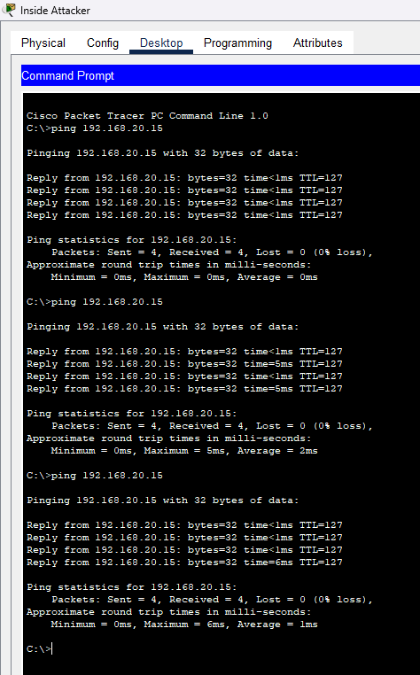
Ping from inside attacker to PC4 Vlan 20 status: success

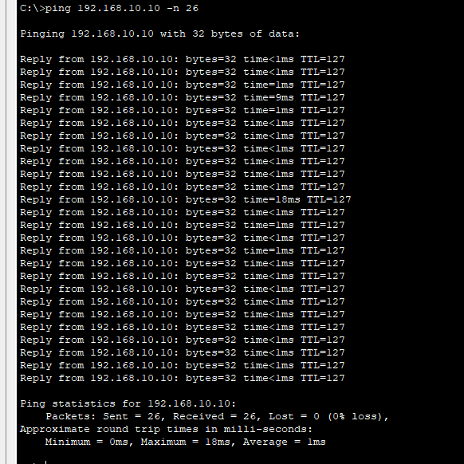
DoS from inside to dhcp server status: success

Test outside Attacker

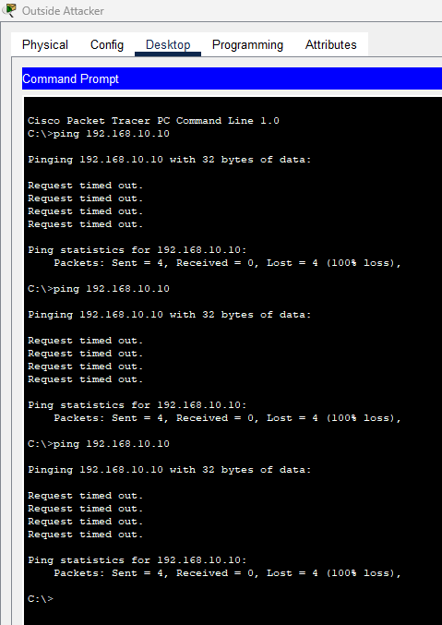
Ping outside attacker to dhcp server status: fail

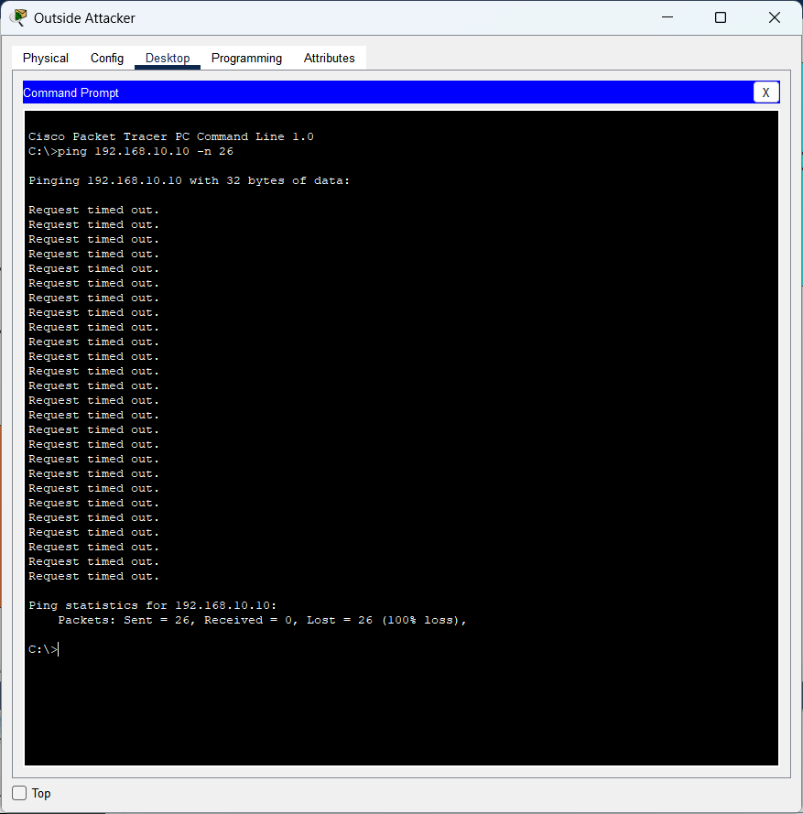
DoS from outside to dhcp server status: denied 26/26 failed

